|  |  |  |  |  |
| --- | --- | --- | --- | --- |
| lambda | Стандартный метод | Var Coordesk метод | Линейный поиск | Рандом эксплорер |
| 0.0001 | In 4093 function calls found v = -316.276 | In 4109 function calls found v = -136.659 | In 4741 function calls found v = -316.432 | In 3335 iterations found v = -316.276 |
| 0.001 | In 10691 function calls found v = -316.368 | In 20878 function calls found v = -136.663 | In 6892 function calls found v = -316.36 | In 8152 iterations found v = -316.367 |
| 0.01 | In 5118 function calls found v = -316.435 | In 16720 function calls found v = -127.713 | In 5090 function calls found v = -316.438 | In 4366 iterations found v = -316.435 |
| 0.1 | In 33258 function calls found v = -127.739 | In 13583 function calls found v = -127.708 | In 7507 function calls found v = -317.04 | In 23902 iterations found v = -127.739 |
| 0.2 | In 10893 function calls found v = -312.588 | In 6371 function calls found v = -302.717 | In 5762 function calls found v = -316.4 | In 7891 iterations found v = -312.588 |
| 0.3 | In 6359 function calls found v = -120.792 | In 9386 function calls found v = -127.694 | In 4741 function calls found v = -316.414 | In 4793 iterations found v = -120.792 |
| 0.4 | In 10320 function calls found v = -317.04 | In 3139 function calls found v = -174.381 | In 7242 function calls found v = -312.588 | In 7461 iterations found v = -317.039 |
| 0.5 | In 8016 function calls found v = -316.368 | In 6619 function calls found v = -164.268 | In 32159 function calls found v = -132.235 | In 6784 iterations found v = -316.368 |
| 0.6 | In 7458 function calls found v = -120.802 | In 3798 function calls found v = -155.678 | In 30056 function calls found v = -311.004 | In 5395 iterations found v = -120.802 |

Измерения проводились для функции lj при inc 1.1 dec 0.9

на графике ниже данные для lambda 0.0001

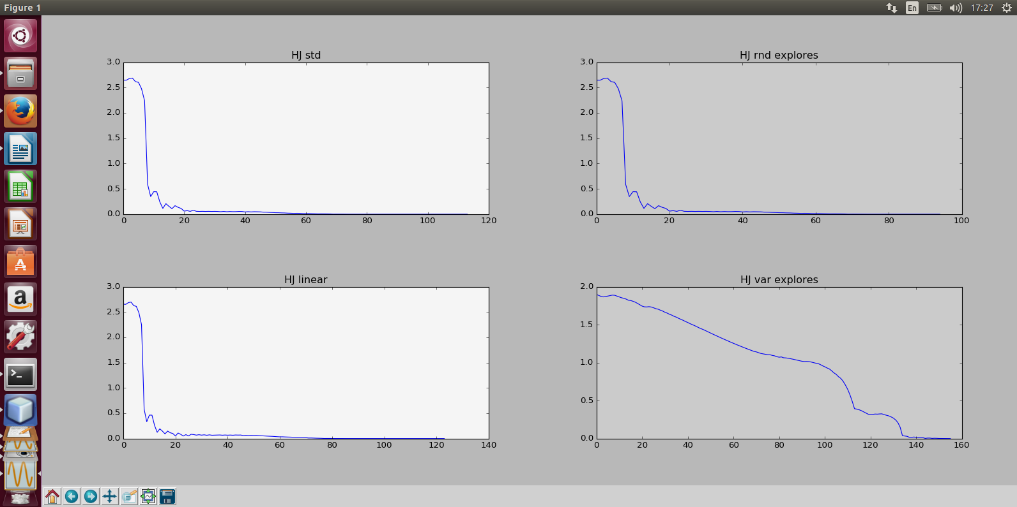

на графике ниже данные для lambda 0.001

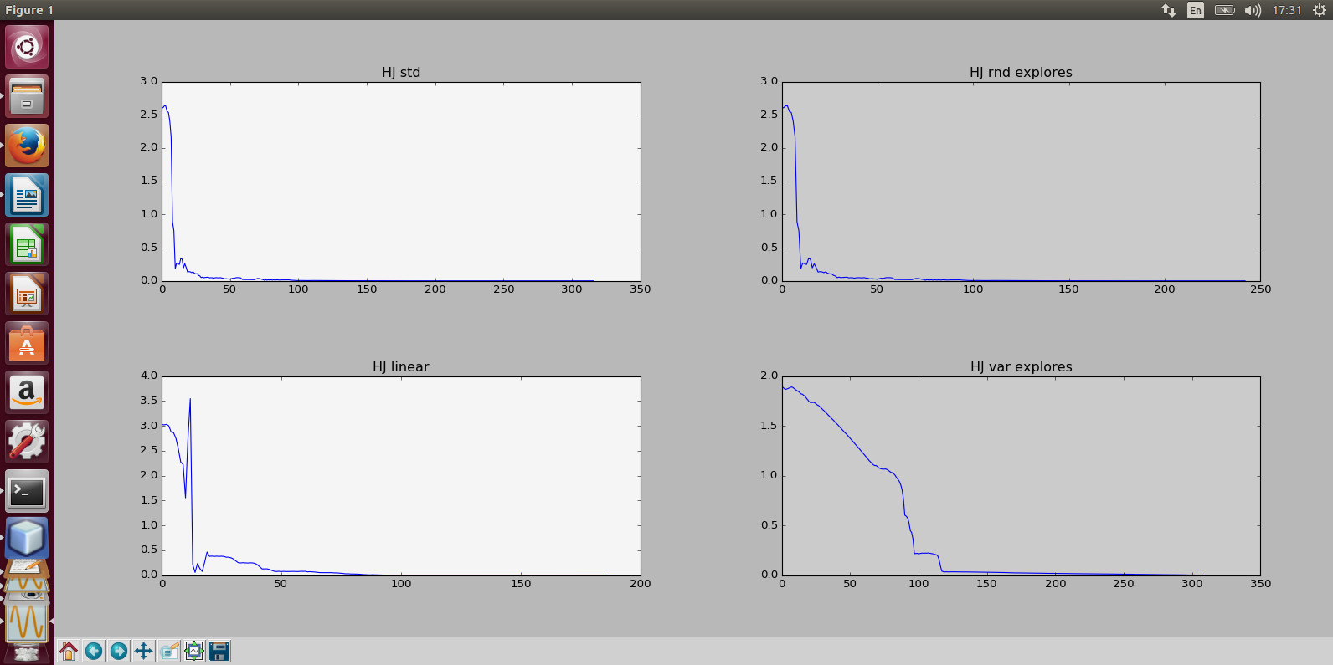

на графике ниже данные для lambda 0.01

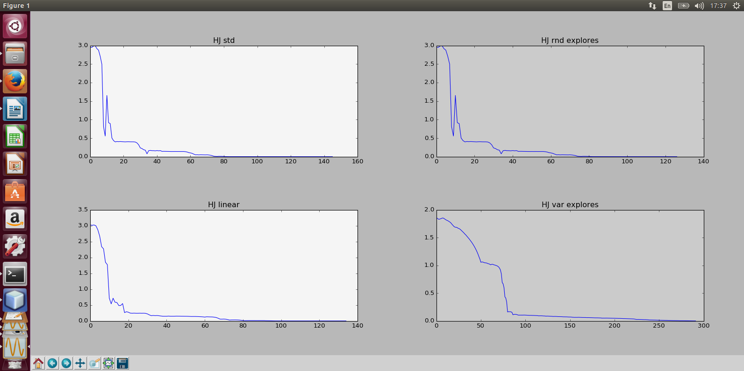

на графике ниже данные для lambda 0.1

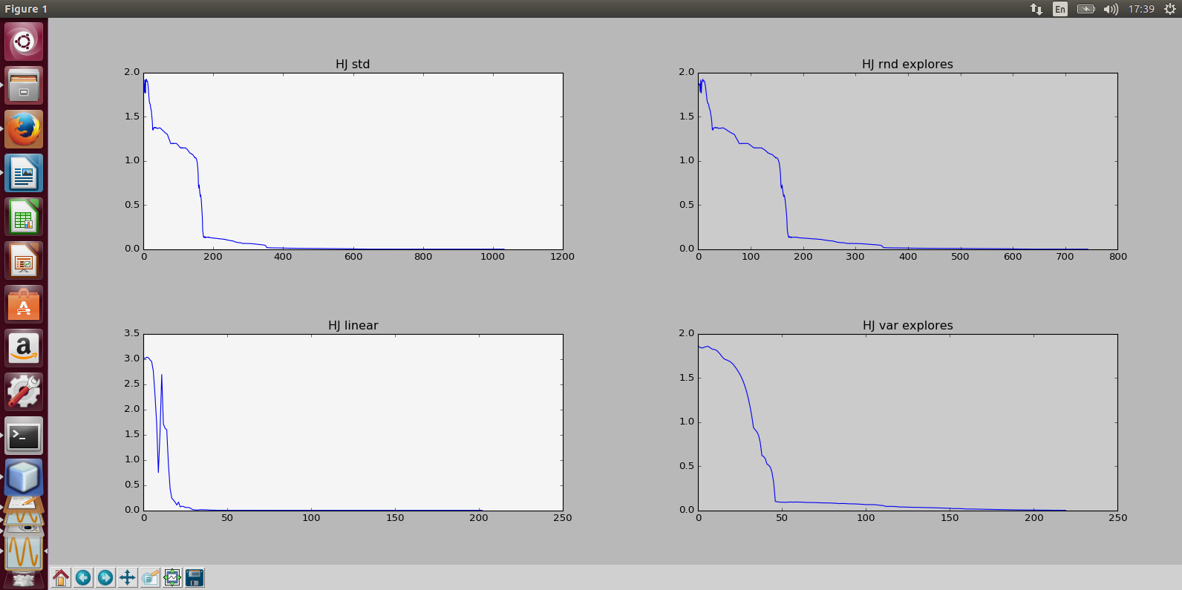

на графике ниже данные для lambda 0.2

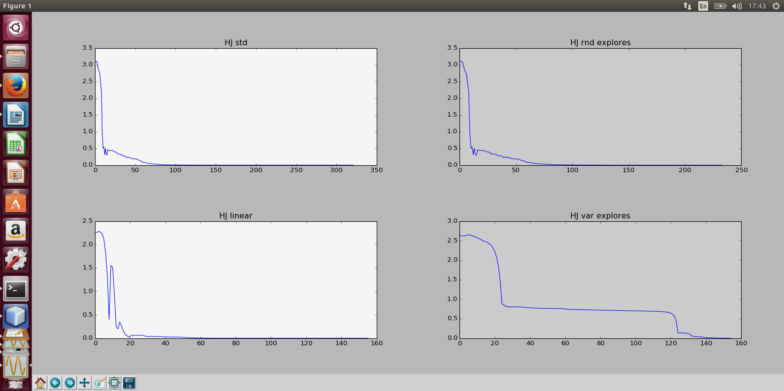

на графике ниже данные для lambda 0.3

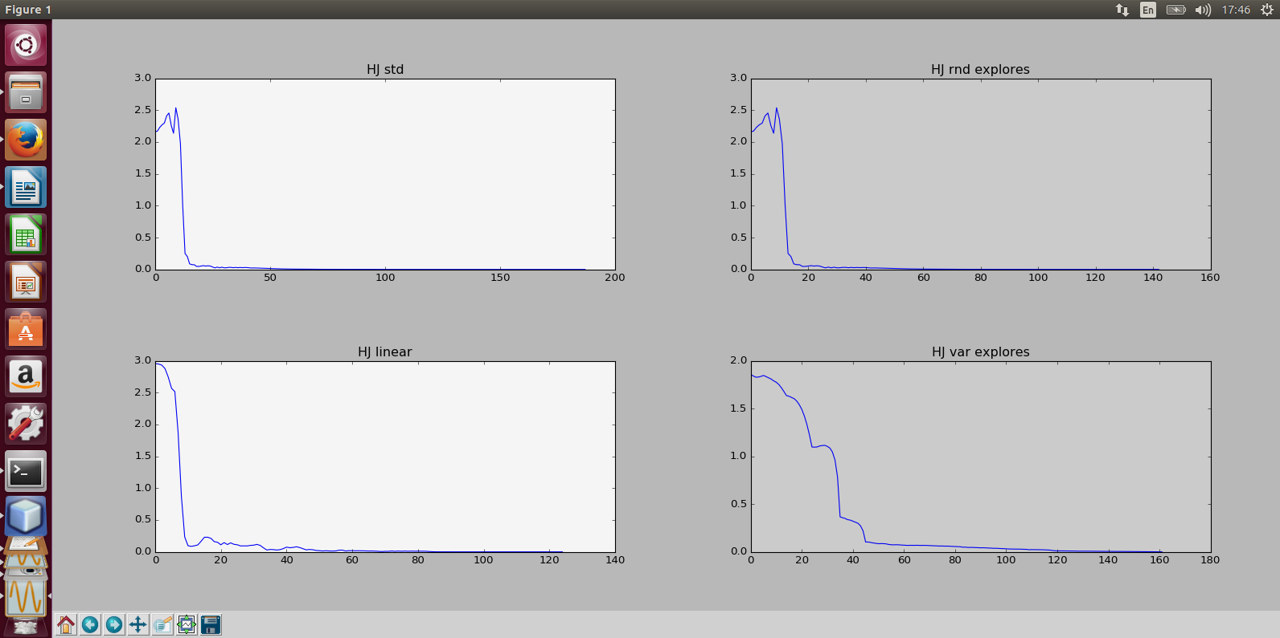

на графике ниже данные для lambda 0.4

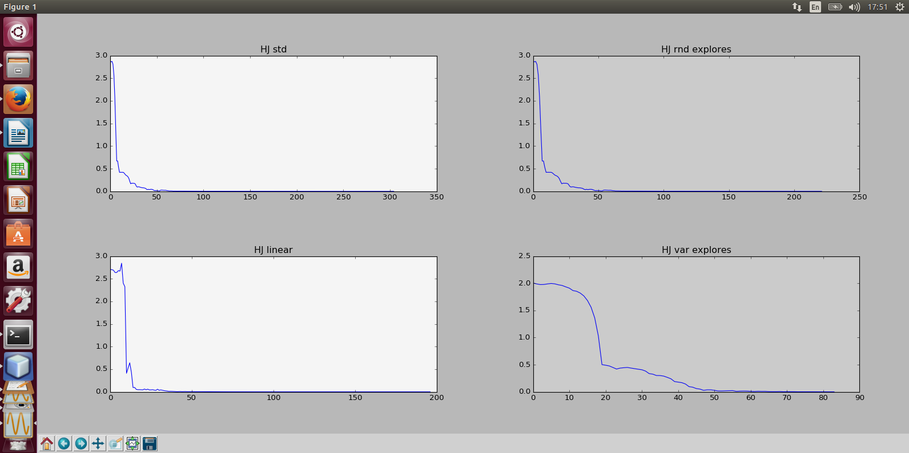

на графике ниже данные для lambda 0.5

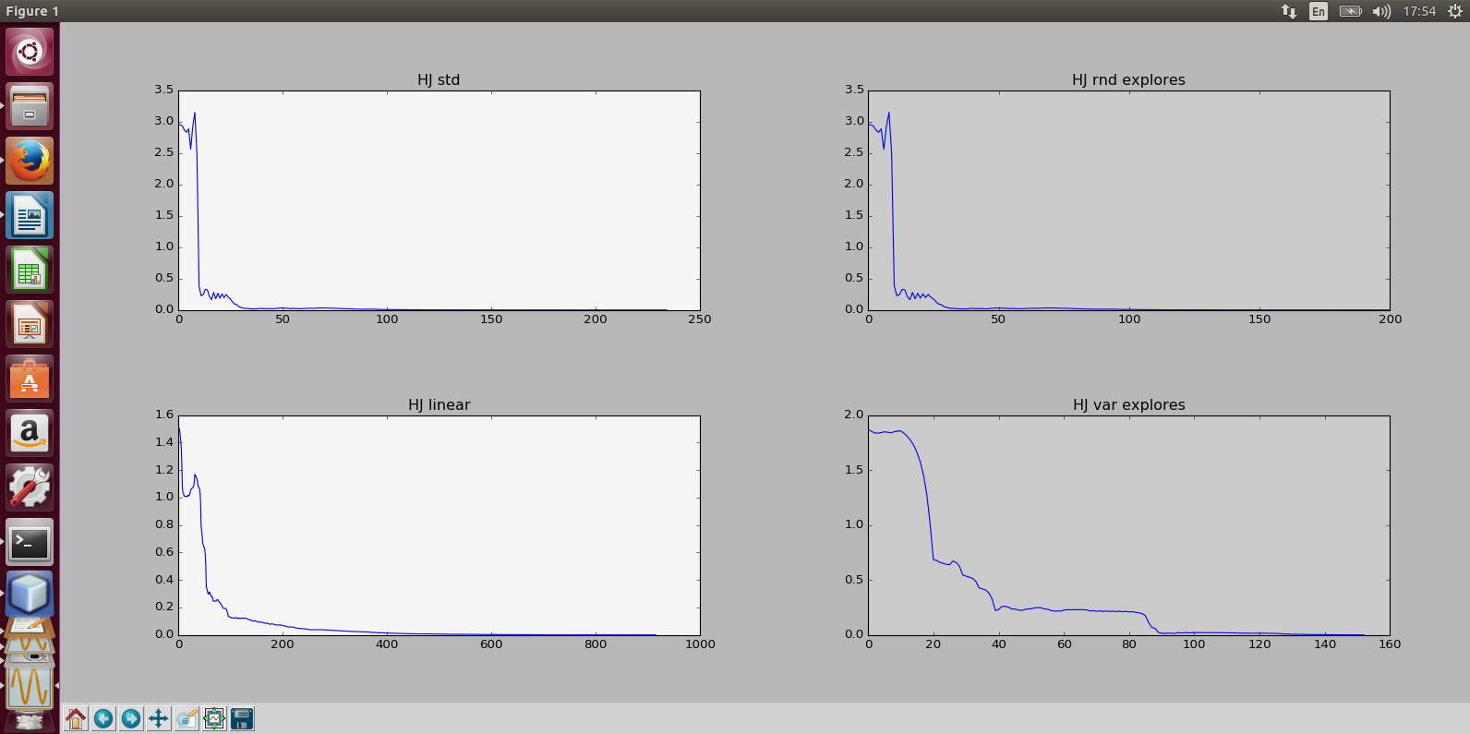

на графике ниже данные для lambda 0.6

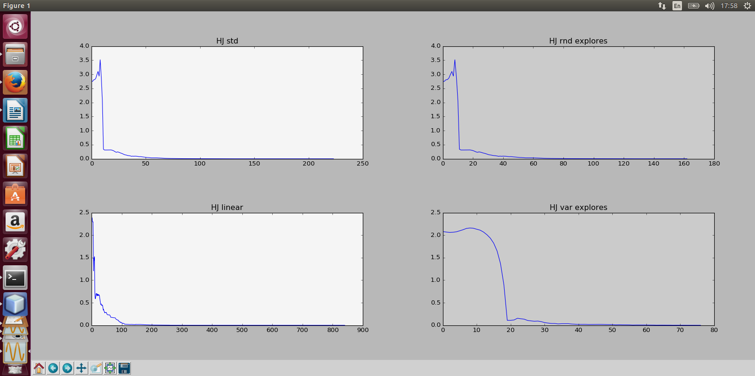

lambda = 0.0001

|  |  |  |  |  |
| --- | --- | --- | --- | --- |
| Lambda inc | Стандартный метод | Var Coordesk метод | Линейный поиск | Рандом эксплорер |
| 1.1 | In 4093 function calls found v = -316.276 | In 4109 function calls found v = -136.659 | In 4741 function calls found v = -316.432 | In 3335 iterations found v = -316.276 |
| 1.5 | In 4690 function calls found v = -316.396 | In 3979 function calls found v = -136.624 | In 5002 function calls found v = -316.395 | In 4154 iterations found v = -316.396 |
| 2 | In 5621 function calls found v = -317.04 | In 6810 function calls found v = -164.268 |  |  |
| 3 |  |  |  |  |
|  |  |  |  |  |
|  |  |  |  |  |
|  |  |  |  |  |
|  |  |  |  |  |

Для tsof

|  |  |  |  |  |
| --- | --- | --- | --- | --- |
| lambda | Стандартный метод | Var Coordesk метод | Линейный поиск | Рандом эксплорер |
| 0.0001 | In 5011 function calls found v = -222.065 | In 6013 function calls found v = -219.693 | In 5551 function calls found v = -222.065 | In 3856 iterations found v = -222.065 |
| 0.001 | In 5205 function calls found v = -222.065 | In 4562 function calls found v = -219.686 | In 4806 function calls found v = -222.065 | In 3594 iterations found v = -222.065 |
| 0.2 | In 7796 function calls found v = -219.694 | In 3287 function calls found v = -219.679 | In 5074 function calls found v = -220.953 | In 5838 iterations found v = -219.694 |
| 0.4 | In 8414 function calls found v = -219.694 | In 4186 function calls found v = -219.682 | In 5584 function calls found v = -220.852 | In 6373 iterations found v = -219.694 |
| 0.6 | In 8168 function calls found v = -219.694 | In 3677 function calls found v = -219.681 | In 9917 function calls found v = -219.694 | In 6051 iterations found v = -219.694 |

График для 0.0001

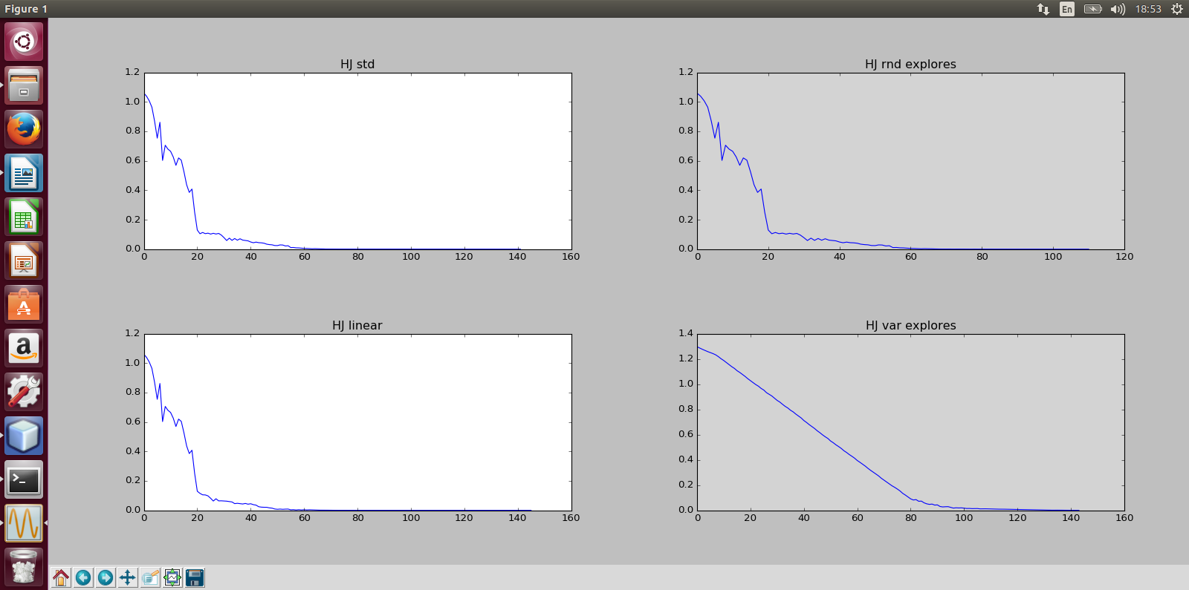

Результаты для функции Розенброка

|  |  |  |  |  |
| --- | --- | --- | --- | --- |
| lambda | Стандартный метод | Var Coordesk метод | Линейный поиск | Рандом эксплорер |
| 0.0001 | In 1848 function calls found v = 3.10905e-13 | In 1534 function calls found v = 0.000178344   |  | | --- | | In 1331 function calls found v = 0.000304193  at [0.982563,0.965467] | | In 2236 function calls found v = 2.2806e-13 | In 1457 iterations found v = 3.60321e-08 |
| 0.001 | In 1619 function calls found v = 1.09473e-12  at [1,1] | In 1331 function calls found v = 0.000304193  at [0.982563,0.965467] | In 2240 function calls found v = 2.89886e-13  at [0.999999,0.999999] | In 1357 iterations found v = 1.18182e-09  at [0.999966,0.999931] |
| 0.2 | In 2129 function calls found v = 1.14736e-12  at [0.999999,0.999998] | In 354 function calls found v = 5.77175e-06  at [1.00233,1.0046] | In 1489 function calls found v = 5.44609e-12  at [1,1] | In 1123 iterations found v = 7.00464e-09  at [0.999495,0.998991] |
| 0.4 | In 1096 function calls found v = 9.38559e-15  at [1,1] | In 492 function calls found v = 0.000630907  at [0.974883,0.950415] | In 2044 function calls found v = 5.60745e-14  at [1,1] | In 629 iterations found v = 7.35817e-08  at [0.999729,0.999457] |
| 0.6 | In 1988 function calls found v = 1.41948e-12  at [0.999999,0.999998] | In 1046 function calls found v = 0.000406353  at [0.979842,0.960094] | In 1752 function calls found v = 1.08438e-13  at [1,1] | In 1300 iterations found v = 1.20477e-07  at [1.00035,1.0007] |

График для 0.0001

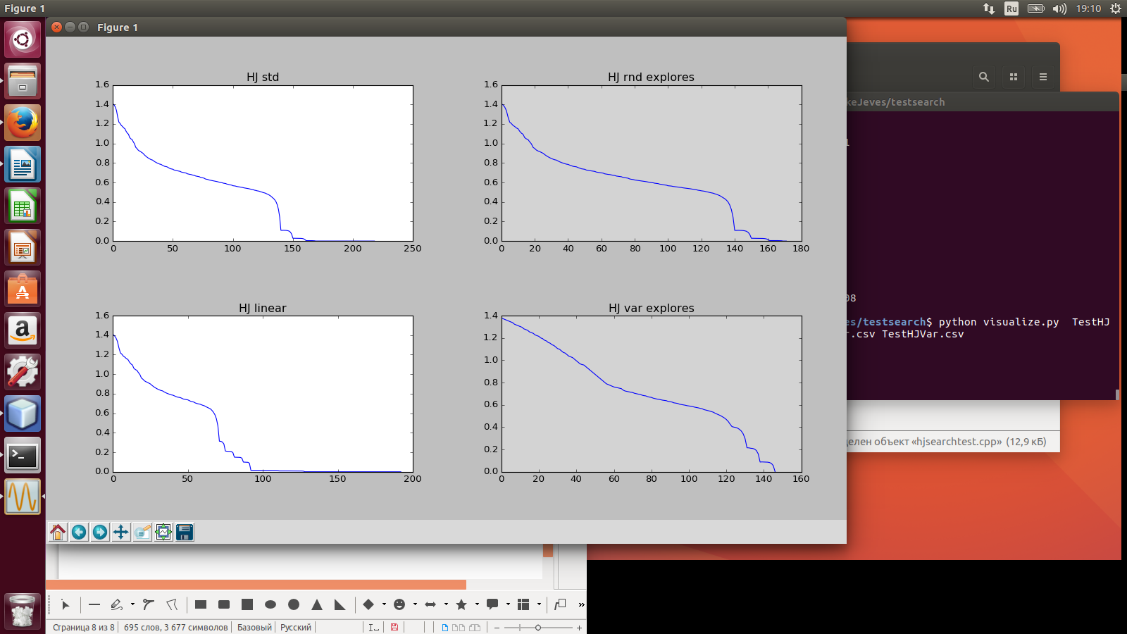

график для 0.001

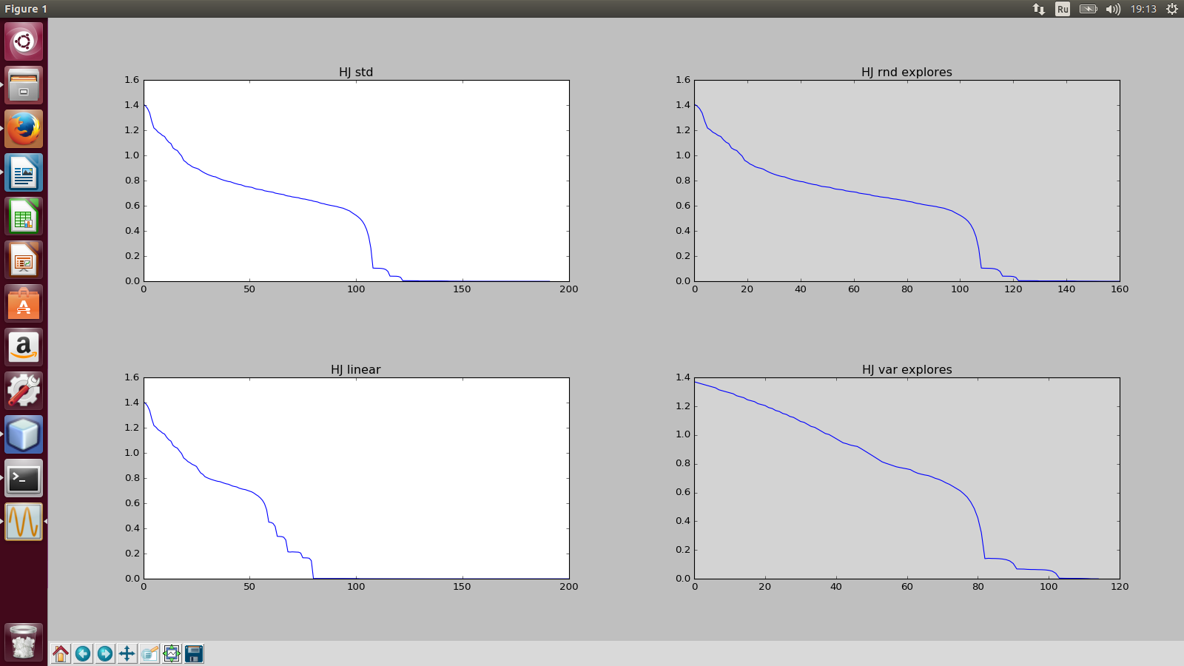

для 0.2

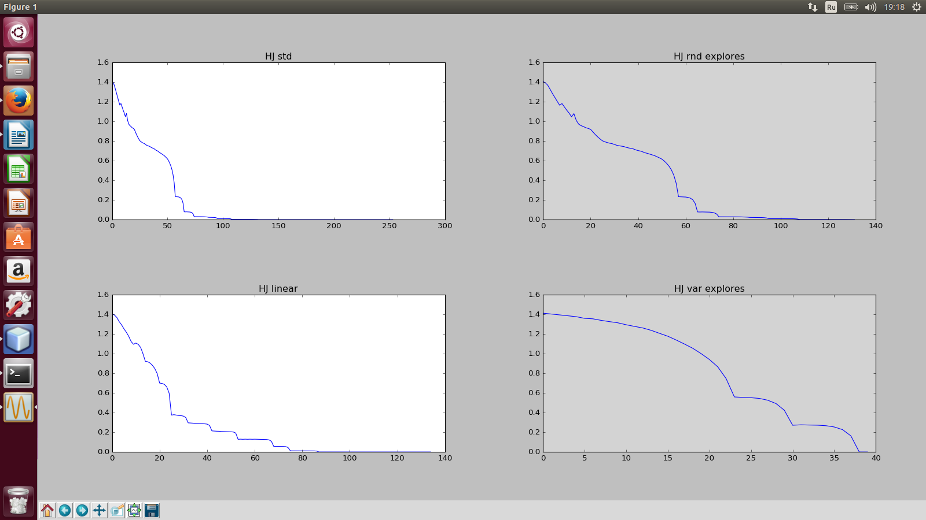

для 0.4

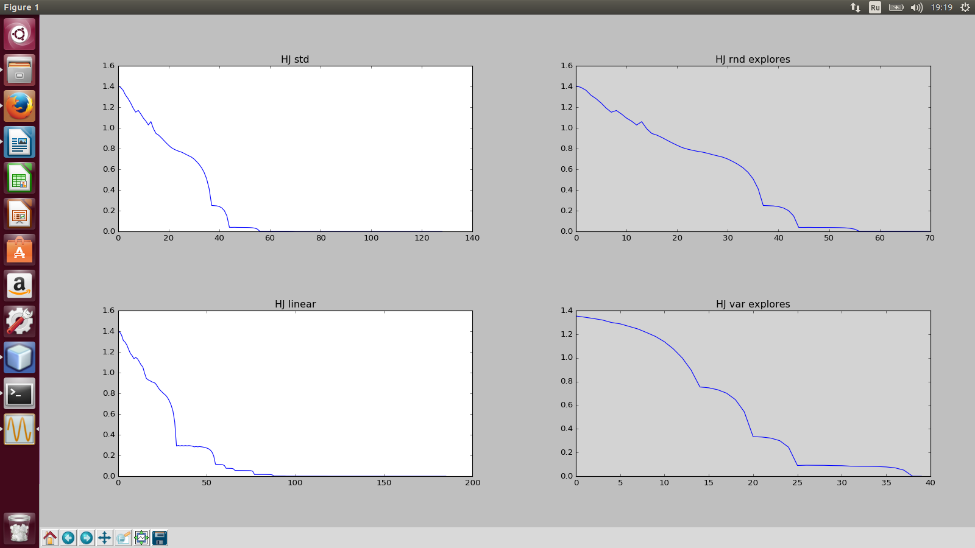

для 0.6

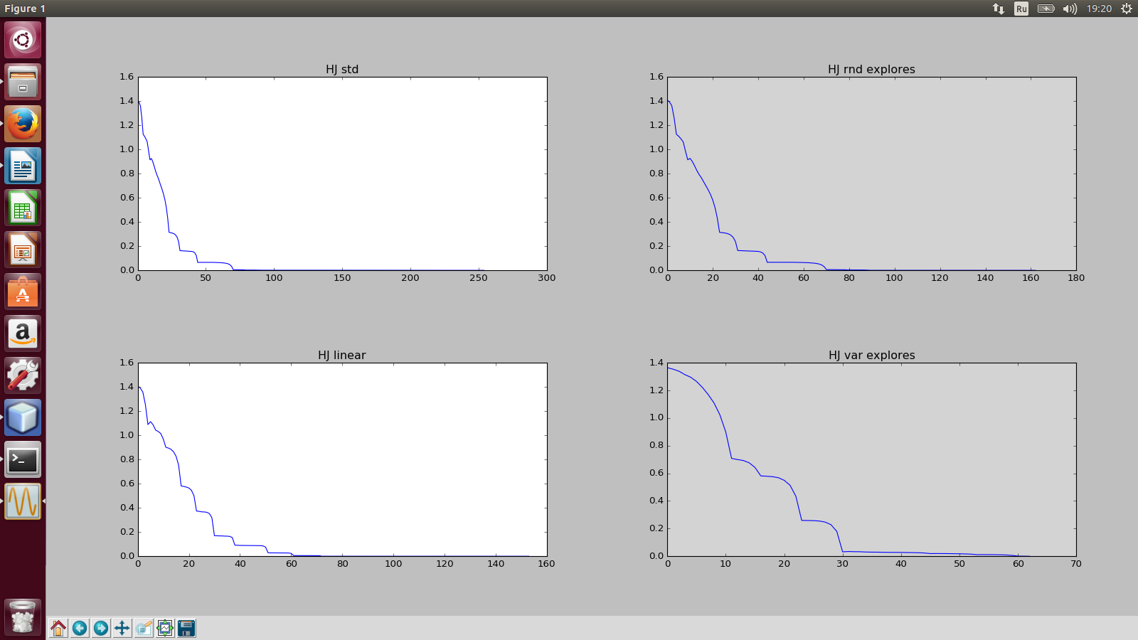

Для функции ��#A#d#j#i#m#a#n

|  |  |  |  |  |
| --- | --- | --- | --- | --- |
| lambda | Стандартный метод | Var Coordesk метод | Линейный поиск | Рандом эксплорер |
| 0.0001 | In 233 function calls found v = -2.02181  at [2,0.105783] | In 385 function calls found v = -2.02181  at [2,0.105779] | In 317 function calls found v = -2.02181  at [2,0.105783] | In 122 function calls found v = -2.02171  at [2,0.113123] |
| 0.001 | In 233 function calls found v = -2.02181  at [2,0.105783] | In 385 function calls found v = -2.02181  at [2,0.105779] | In 317 function calls found v = -2.02181  at [2,0.105783] | In 122 function calls found v = -2.02171  at [2,0.113123] |
| 0.2 | In 224 function calls found v = -2.02181  at [2,0.105783] | In 183 function calls found v = -2.02181  at [2,0.105769] | In 334 function calls found v = -2.02181  at [2,0.105783] | In 82 function calls found v = -2.02069  at [2,0.130212] |
| 0.4 | In 234 function calls found v = -2.02181  at [2,0.105783] | In 180 function calls found v = -2.02181  at [2,0.105815] | In 272 function calls found v = -2.02181  at [2,0.105783] | In 86 function calls found v = -2.00945  at [2,0.18819] |
| 0.6 | In 246 function calls found v = -2.02181  at [2,0.105783] | In 167 function calls found v = -2.02181  at [2,0.105719] | In 311 function calls found v = -2.02181  at [2,0.105783] | In 107 function calls found v = -2.01186  at [2,0.0340891] |

0.0001

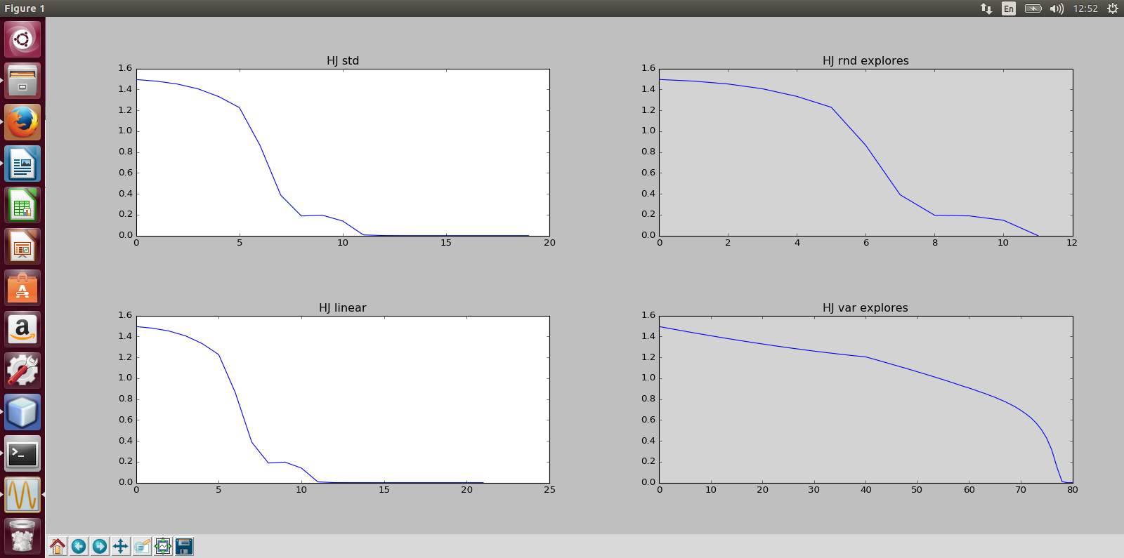

0.4

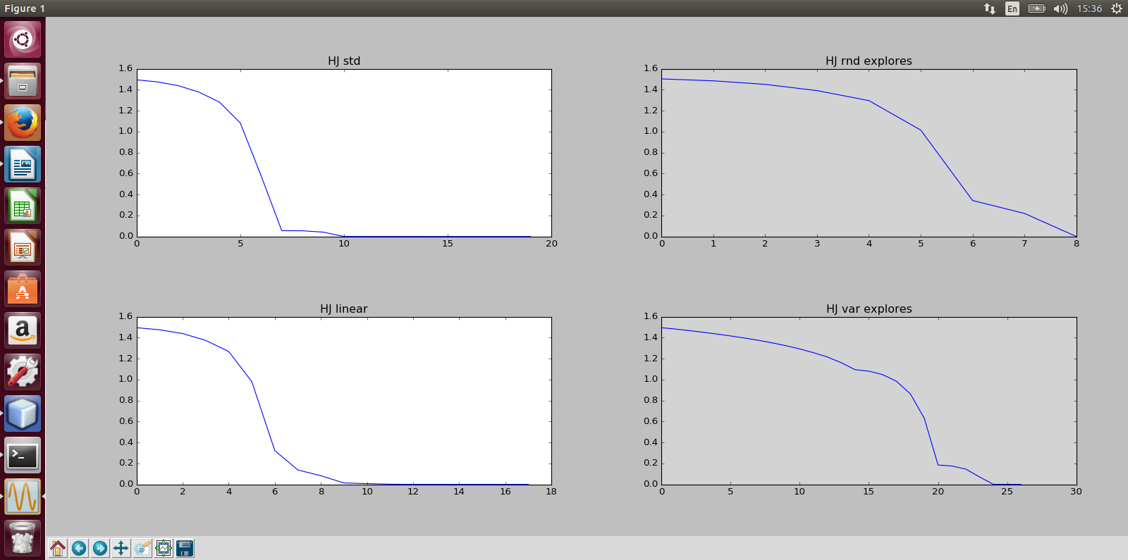

��#A#c#k#l#e#y#3

|  |  |  |  |  |
| --- | --- | --- | --- | --- |
| lambda | Стандартный метод | Var Coordesk метод | Линейный поиск | Рандом эксплорер |
| 0.0001 | In 199 function calls found v = 82.4617  at [-32,-32] | In 444 function calls found v = 195.123  at [-1.41884,-0.669518] | In 257 function calls found v = 82.4617  at [-32,-32] | In 161 function calls found v = 82.4617  at [-32,-32] |
| 0.001 | In 199 function calls found v = 82.4617  at [-32,-32] | In 383 function calls found v = 195.123  at [-1.41884,-0.669428] | In 257 function calls found v = 82.4617  at [-32,-32] | In 161 function calls found v = 82.4617  at [-32,-32] |
| 0.2 | In 178 function calls found v = 82.4617  at [-32,-31.6444] | In 257 function calls found v = 195.123  at [-1.41892,-0.669337] | In 424 function calls found v = 195.123  at [-1.41888,-0.669418] | In 102 function calls found v = 195.138  at [-1.46577,-0.660391] |
| 0.4 | In 180 function calls found v = 82.4617  at [-32,-32] | In 221 function calls found v = 195.123  at [-1.41885,-0.669499] | In 469 function calls found v = 195.123  at [-1.41888,-0.669418] | In 73 function calls found v = 195.133  at [-1.3062,-0.76765] |
| 0.6 | In 291 function calls found v = 195.123  at [-1.41888,-0.669418] | In 213 function calls found v = 195.123  at [-1.41883,-0.669472] | In 384 function calls found v = 195.123  at [-1.41888,-0.669418] | In 78 function calls found v = 195.144  at [-1.47677,-0.645876] |

0.0001

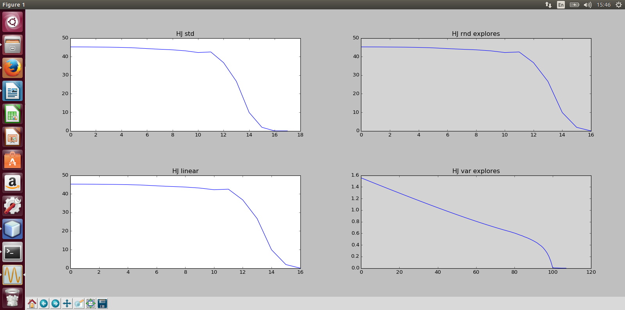0.4

